CHAPTER 1

PICTURING DISTRIBUTIONS WITH GRAPHS

1. Employees at a large company are surveyed about the status of their health insurance status. Employees are coded as “1” if health insurance is obtained through the company’s benefit program, “2” if it obtains health insurance from another source (e.g., through a spouse’s employment benefit program), or “0” if the employee does not have health insurance. The variable class standing is
a. numerical.
* b. categorical.
c. quantitatively categorical.
d. All of the above

2. A company has three divisions and three conference rooms for meetings. To keep track of the use of their facilities, for each meeting held in the company, the division holding the meeting is recorded, the room for the meeting is recorded, and the length of time of the meeting is recorded. Which of the variables is quantitative?
a. the division holding the meeting
b. the conference room for the meeting
* c. the length of time for the meeting
d. All of the above

3. A description of different houses for sale includes the following variables. Which of the variables is categorical?
a. the square footage of the house
* b. whether or not the house has a finished basement
c. the monthly electric bill
d. All of the above

4. The following are some of the variables from a survey conducted by the U.S. Census Bureau. Which of the variables is quantitative?
a. the number of people living in a household
b. the total household gross income
c. the ages of household residents
* d. All of the above

5. As part of a data base on new births at a hospital, some variables recorded are the age of the mother, marital status of the mother (e.g., single, married, divorced), weight of the baby, and sex of the baby. Of these variables
a. the individuals described are mothers and babies involved in births at a hospital.
b. age of mother and weight of baby are quantitative variables.
c. sex and marital status are categorical variables.
* d. All of the above.

6. When drawing a histogram, it is important to
a. eliminate the extremes to minimize the effect of skewness.
b. choose class intervals so all contain a similar number of observations.
c. make certain the mean and median are contained in the same class interval, so the correct type of skewness can be identified.
* d. label the vertical axis, so the reader can determine the counts or percent in each class interval.

7. In drawing a histogram, which of the following suggestions should be followed?
a. No bar should be taller than it is wide.
b. Generally, bars should be square, so both the height and width equal the class count.
c. The scale of the vertical axis should be that of the variable whose distribution you are displaying.
* d. None of the above

Use the following to answer Questions 8 and 9.

A poll was conducted of more than 50,000 buyers of new cars 90 days after their purchase. The data on problems per 100 vehicles for vehicles made by Toyota and General Motors are given in the time plot below for the years 1998–2004. The solid line is for General Motors and the dashed line is for Toyota.

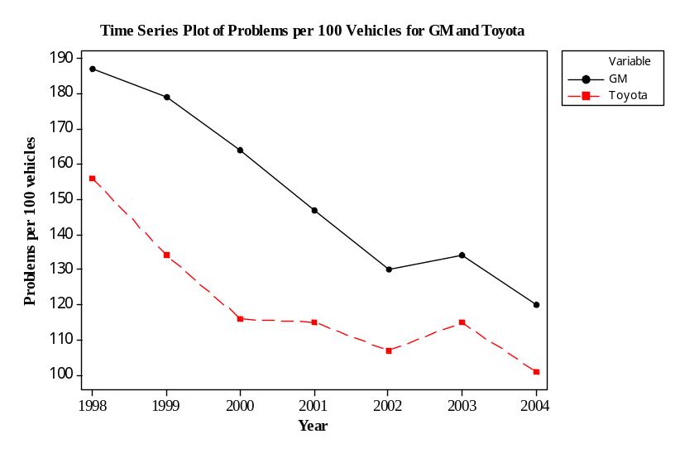
8. In 2002, the number of problems per 100 vehicles was
a. about twice as high for General Motors as for Toyota.
b. about 20% higher for General Motors than for Toyota.
c. about 20% higher for Toyota than for General Motors.
* d. about 20% higher for General Motors than for Toyota.

9. Which of the following is a true statement?
a. The quality of cars is getting poorer for both companies.
* b. The number of problems was higher for General Motors than for Toyota in each year.
c. The difference in the number of problems per 100 vehicles between General Motors and Toyota is less than 30 for each year.
d. All of the above

Use the following to answer Questions 10 and 11.

A large university is divided into six colleges, with most students graduating from four of these colleges. The following bar chart gives the distribution of the percent graduating from the four most popular colleges in 2003.

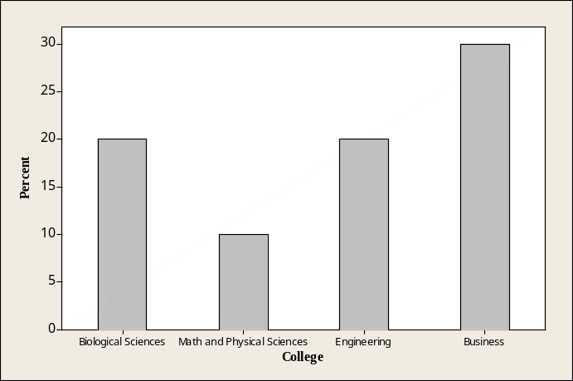

10. The percent of students graduating from either Engineering or Business is
a. approximately 30%.
b. approximately 40%.
* c. approximately 50%.
d. over 60%.

11. Which of the following is a correct statement?
a. A timeplot of the 2003 distribution would be more informative.
b. The bar graph is skewed to the right.
c. The bar graph is skewed to the left.
* d. It would be correct to make a pie chart if you added an “Other” category.

Use the following to answer Questions 12–14.

The histogram below shows the time visitors to a museum spent browsing an exhibit on a Saturday. There were 300 visitors that day. The following histogram is of the data collected.
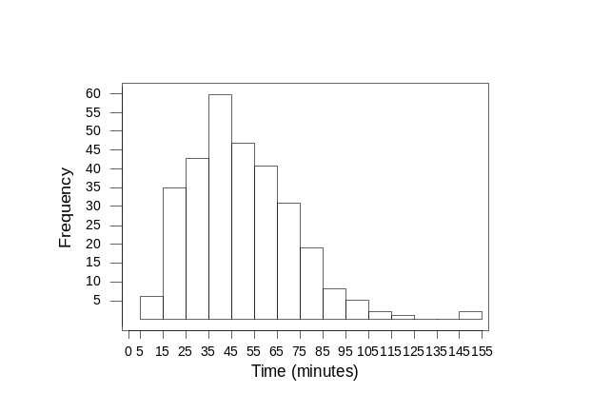

12. The number of visitors that spent less than 25 minutes at the museum that day is closest to
a. 25.
* b. 30.
c. 60.
d. 80.

13. The percent of visitors spending more than 85 minutes at the museum is closest to
* a. about 5%.
b. about 20%.
c. about 30%.
d. over 40%.

14. The histogram
a. is skewed right.
b. has an outlier.
c. is asymmetric.
* d. All of the above

Use the following to answer Questions 15 and 16.

The following histogram represents the distribution of acceptance rates (percent accepted) among 25 business schools in 2004. In each class interval, the left endpoint is included but not the right, so the class intervals are 10 ≤ rate < 15, 15 ≤ rate < 20, etc.
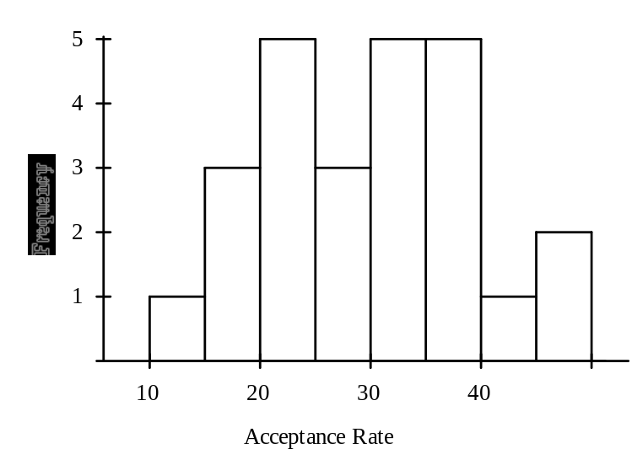

15. What percent of the schools have an acceptance rate below 15%?
a. 1%
* b. 4%
c. 12%
d. 16%

16. The number of schools with acceptance rates over 30% is
a. 5.
b. 12.
c. 10.
* d. 13.

The following information is for Questions 17–19.

The stemplot below displays midterm exam scores for the 34 students taking a Calculus course. The highest possible test score was 100. The teacher declared that an exam grade of 65 or higher was good enough for a grade of “C” or better.

3 6 8
4 1 4 8
5 3 3 4 4
6 2 3 3 5 5 6 7
7 0 0 1 2 3 5 6 6 8 8 9
8 1 1 3 5
9 0 3 9

17. This stemplot is most similar to
a. a boxplot of the data.
b. a time plot of the data with the observations taken in increasing order.
* c. a histogram with class intervals 30 score < 40, 40 score < 50, etc.
d. reporting the five-point summary for the data, with the mean.

18. Which of the following statements is true?
a. All test scores were between 36 and 99.
b. Eleven students scored between 70 and 79.
c. The distribution of test scores is about symmetric.
* d. All of the above

19. The percent of students earning a grade of “C” or higher (as declared by the teacher) is closest to
a. 35%.
b. 50%.
* c. 65%.
d. 80%.

Use the following to answer Questions 20 and 21.

The following is a histogram showing the distribution of the average property damage caused by tornadoes per year over the period 1950 to 1999 in each of the 50 states and Puerto Rico. The data are in millions of dollars and the class intervals are “0 to < 10,” “10 to < 20,” and so forth.
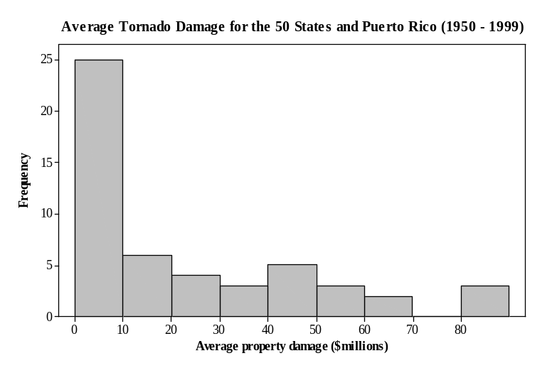
20. The percent of the data with average property damage of under 20 million dollars is about
a. 20%.
b. 30%.
c. 40%.
* d. 60%.

21. The histogram
a. is skewed to the right.
b. shows one high outlier.
c. has a center of about 10 million dollars.
* d. All of the above

Use the following to answer Questions 22 and 23.

A sample of 40 employees from the local Honda plant was obtained and the length of time (in months) worked was recorded for each employee. A stemplot of these data follows. In the stemplot, 5|2 represents 52 months.

5 2 2 3 3 4 5 7 8 9 9
6 0 0 0 2 3 4 4 4 5 6 7 7 8 8 8 9
7 3 4 5 5 6 6 7 7 7 8 8 9 9
8
9 8

22. What would be a better way to represent this data set?
a. Display the data in a time plot.
* b. Split the stems.
c. Use a pie chart.
d. Use a histogram with class width equal to 10.

23. The percentage of employees in the sample that have worked at the plant for less than 5 years is
a. approximately zero.
b. 10%.
c. 15%.
* d. 25%.

Use the following to answer Questions 24 and 25.

Consumers’ Union measured the gas mileage per gallon of 38 1998−99 model automobiles on a special test track. The following pie chart provides information about the country of manufacture of the model cars that Consumers’ Union used.

24. Based on this pie chart, we may conclude that
a. Japanese cars get significantly lower gas mileage than cars of other countries. This is because their slice of the pie is at the bottom of the chart.
* b. more than half of the cars in the study were from the United States.
c. Swedish cars get gas mileages that are between those of Japanese and U.S. cars.
d. Mercedes Benz, Audi, Porsche, and BMW represent approximately one quarter of the cars tested.

25. Which of the following bar graphs is equivalent to the pie chart?
a.

* b.

c.

d.

Use the following to answer Questions 26 and 27.

The bar graph below gives the distribution of the most popular colors for cars and light trucks sold globally in 2010.
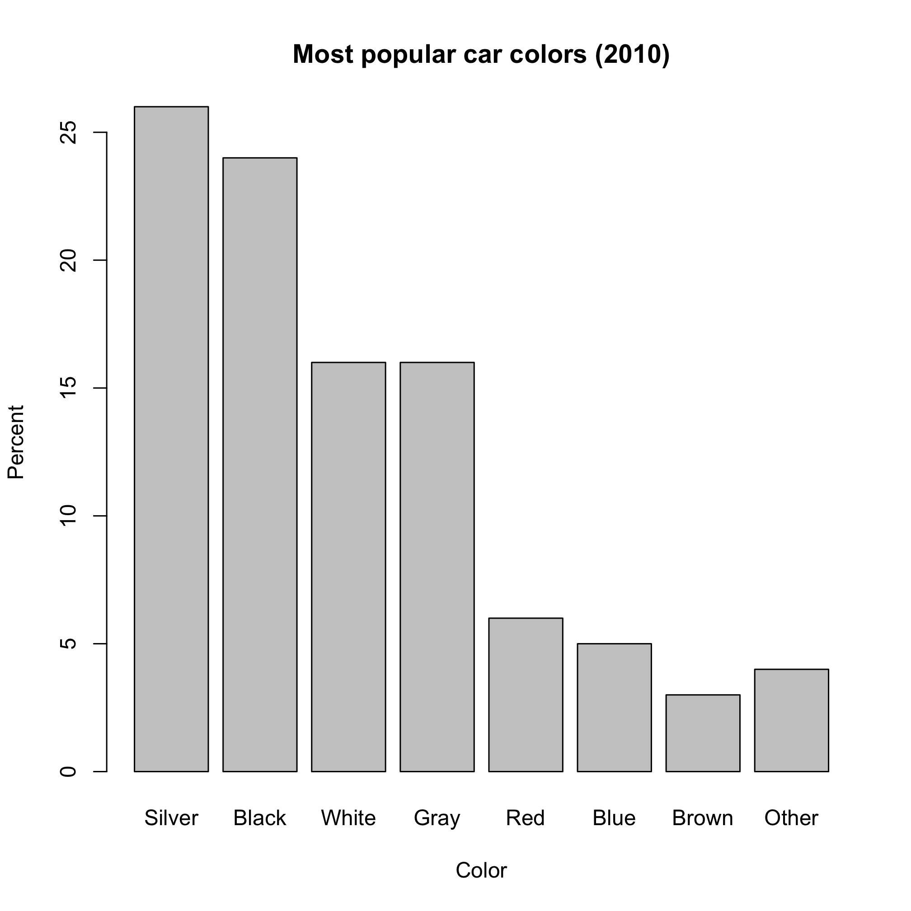

26. Approximately what percent of cars sold in 2010 were white?
a. 6%
b. 9%
* c. 16%
d. 24%

27. Which of the following kinds of plots would also be appropriate for these data?
a. a time series plot
* b. a pie chart.
c. a histogram.
d. All of the above

